Supplemental Materials
Fig. S1. SEM images of T10 group soil samples at 2000x magnification after the reinforcement stage, and EDS analysis images of soil samples after the reinforcement stage: (a) reinforcement anode; (b) reinforcement middle; (c) reinforcement cathode; (d) reinforcement EDS
Fig. S2. FTIR and XRD spectra of soil after remediation and reinforcement phases

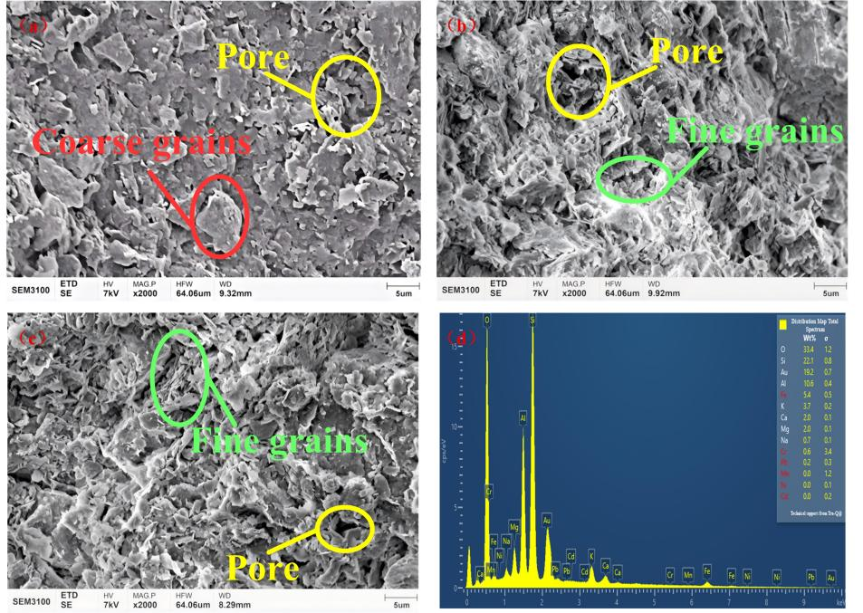
Fig. S1. SEM images of T10 group soil samples at 2000x magnification after the reinforcement stage, and EDS analysis images of soil samples after the reinforcement stage: (a) reinforcement anode; (b) reinforcement middle; (c) reinforcement cathode; (d) reinforcement EDS

Fig. S2. FTIR and XRD spectra of soil after remediation and reinforcement phases

